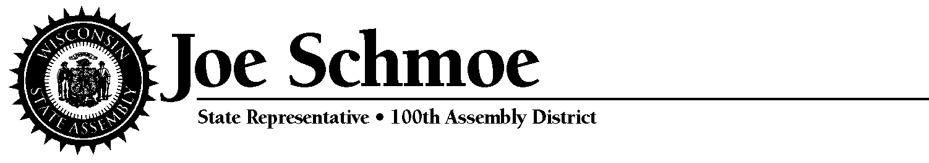

FOR IMMEDIATE RELEASE may 13, 2013
Contact: State Representative Joe Schmoe (608) 266-0000

Rep. Schmoe Secures Broadband Availability for Rural Areas
Madison, WI – Today, Rep. Joe Schmoe (R-High Plaines) issued the following statement after the Joint Committee on Finance (JFC) voted to ensure that $4.3 million in funding will be available for a broadband expansion grant program and included in the 2013- 2015 State Budget.

“Funding for broadband services was going to be decreased dramatically, when my fellow Republican colleagues and I wrote a letter to the Joint Committee on Finance. Our letter helped to ensure that the 23 percent of households in Wisconsin with no broadband internet access will have services available.
“Rural areas throughout the state deserve the same availability to broadband services that urban areas receive. Too often, many rural communities are either underserved or do not receive any type of broadband access at all.
“This funding helps puts rural areas at an advantage with more opportunity in economic growth, job creation, educational opportunities, healthcare information, and much more, said Rep. Schmoe.”
###

