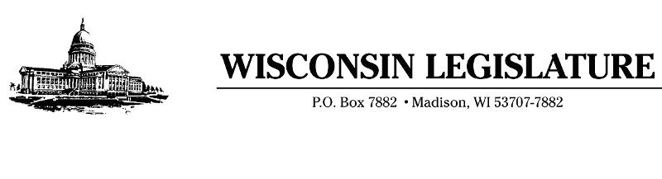

July 28, 2020

Al Mollerskov

District Administrator

Union Grove High School

3433 S Colony Ave

Union Grove, WI 53182

Dear Mr. Mollerskov,

Thank you for your service to the students, families and teachers in your school district. We know that many educators and superintendents across the state and nation are in the midst of making important and unusual education decisions for families during these tumultuous times. We appreciate your hard work, and like you, we are hearing from many parents, teachers and members of our communities about the upcoming school year. We wish to take this opportunity to share some of those concerns, and ask that you consider our input as you start the fall school year.

We understand that as part of your local decision-making process, some of you are considering virtual education as part of your strategy. There is nearly universal agreement among educators that most students are taught more effectively in a classroom. In a virtual setting, it is often impossible to provide adequate oversight of student engagement and to give additional assistance to those who are struggling.

Based on feedback we’ve received from across the state, the majority of parents have a strong desire for their children to return to the classroom on a daily basis in the 2020-2021 school year. The state is minimally obligated to provide students the opportunity for a sound, basic education, but we wish to ensure all students have access to the best education possible. To that end, we ask that you consider opening your doors this fall to provide every student with an in-class experience.

If your district does decide to implement virtual learning, we strongly encourage you to ensure teachers are physically present in their classrooms. This would entail teaching students via a virtual platform, but in a similar manner, and with the same curriculum as if learning were done in person. Teachers would be able to utilize all of their classroom resources while providing students with open, direct and live communication at acceptable social distance.

Last spring, there were numerous reports of families that did not engage in virtual learning provided by their district, which is cause for great concern. Taking steps such as scheduled live courses would allow teachers to take attendance while giving parents the opportunity to provide a successful learning environment. Many parents are continuing to work from home, which means families must share access to computers and internet as they work and learn. Creating a scheduled day will allow both students and parents to better prepare and overcome those sometimes-substantial limitations during this difficult period.

As you know, many courses are not conducive to a virtual learning environment. We encourage your planning to include providing access to certain school facilities, on at least a limited basis, to students involved in courses that cannot be taught without physical engagement, specialized equipment and arms-length supervision.

We also want to encourage you to develop a plan to allow athletic facilities in your district to be open for students and families to use safely this upcoming school year. Gymnasiums and athletic facilities (especially those outdoors) could be open with certain restrictions allowing families to exercise, especially during the winter months. The opportunity to participate in physical activity safely on school grounds will benefit students mentally and emotionally as well.

Finally, as you know, we are staunch advocates for families having access to the educational options best for their children. We have asked the Department of Public Instruction to promulgate a rule allowing broader access to the open enrollment process when the student’s best interest is at stake. As an educator, you understand each student learns in a unique way and we ask you to consider a parents’ request to place their child in the best environment for their needs.

We appreciate the fact that the people in your communities are very passionate about the difficult decisions that are directly before you. We are heartened by the level of engagement and thoughtfulness with which districts across the state are tackling these challenges facing our education system during the COVID-19 pandemic. We are excited to see all the ways that, working with parents and communities, districts will provide a strong education for our children.

Sincerely,

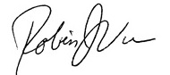 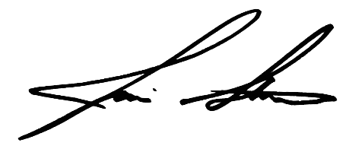

Rep. Robin J. Vos Rep. Jim Steineke  
Assembly Speaker Majority Leader

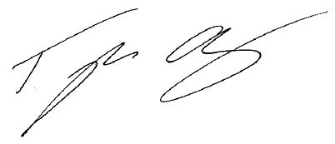 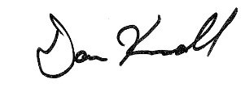

Rep. Tyler August Rep. Dan Knodl  
Speaker Pro-Tempore Majority Caucus Chair

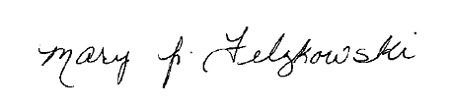 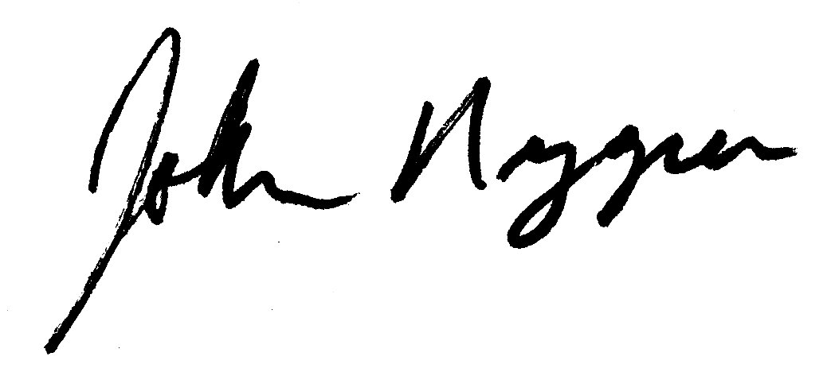

Rep. Mary Felzkowski Rep. John Nygren  
Assistant Majority Leader Assembly Chair Joint Committee on Finance

 

Rep. Joan Ballweg Rep. Mark Born  
41st Assembly District 39th Assembly District

 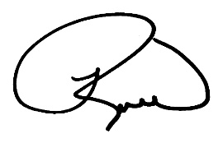

Rep. Janel Brandtjen Rep. Robert Brooks  
22nd Assembly District 60th Assembly District

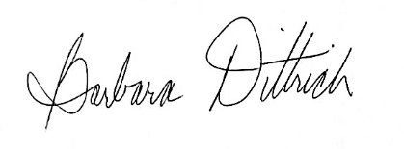 

Rep. Barbara Dittrich Rep. Cindi Duchow  
38th Assembly District 99th Assembly District

 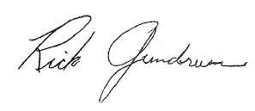

Rep. James Edming Rep. Rick Gundrum  
87th Assembly District 58th Assembly District

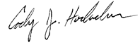 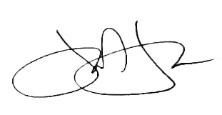

Rep. Cody Horlacher Rep. John Jagler   
33th Assembly District 37th Assembly District

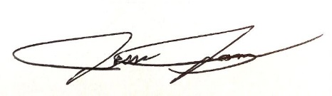 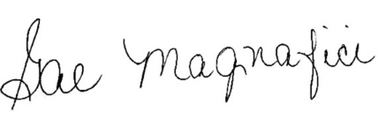

Rep. Jesse James Rep. Gae Magnafici

68th Assembly District 28th Assembly District

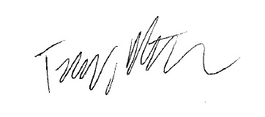 Rep. Terry Katsma Rep. Joel Kitchens  
26th Assembly District 1st Assembly District

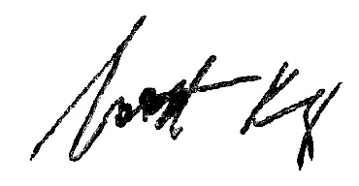 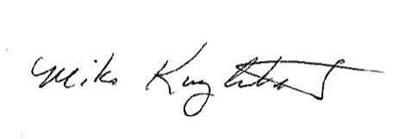

Rep. Scott Krug Rep. Mike Kuglitsch  
72th Assembly District 84th Assembly District

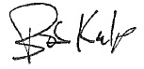 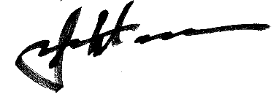

Rep. Bob Kulp Rep. John Macco

69th Assembly District 88th Assembly District

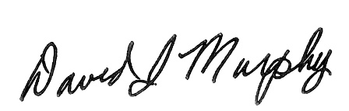 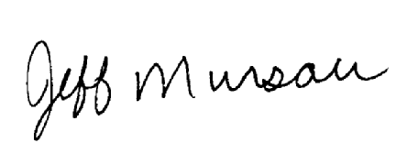

Rep. Dave Murphy Rep. Jeffrey Mursau  
56th Assembly District 36th Assembly District

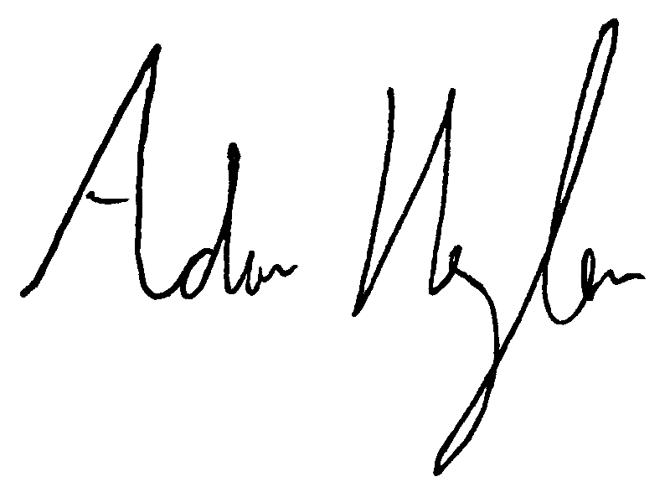 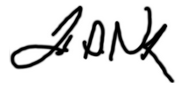  
Rep. Adam Neylon Rep. Todd Novak  
98th Assembly District 51st Assembly District

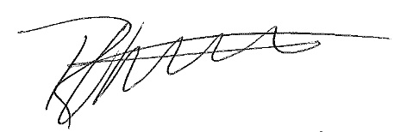 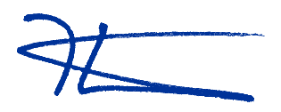

Rep. Robert Wittke Rep. Kevin Petersen

62nd Assembly District 40th Assembly District

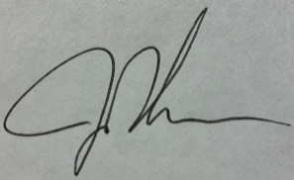

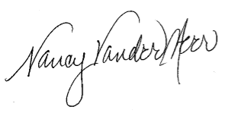

Rep. Jon Plumer Rep. Nancy VanderMeer

42nd Assembly District 70th Assembly District

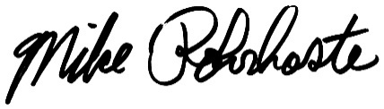 

Rep. Mike Rohrkaste Rep. David Steffen   
55th Assembly District 4th Assembly District

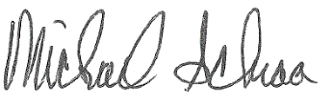 

Rep. Michael Schraa Rep. Ken Skowronski  
53rd Assembly District 82nd Assembly District

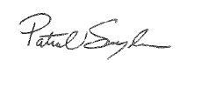 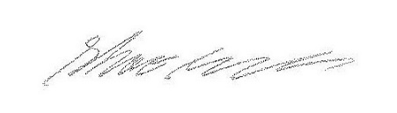

Rep. Pat Snyder Rep. Shae Sortwell  
85th Assembly District 2nd Assembly District  
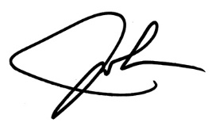 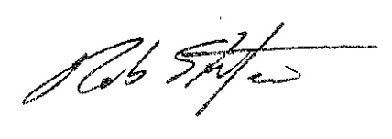

Rep. John Spiros Rep. Rob Stafsholt  
86th Assembly District 29th Assembly District

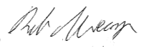 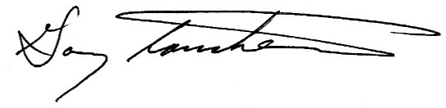

Rep. Rob Swearingen Rep. Gary Tauchen

34th Assembly District 6th Assembly District

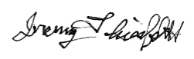 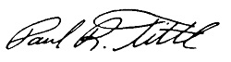

Rep. Jeremy Thiesfeldt Rep. Paul Tittl  
52nd Assembly District 25th Assembly District 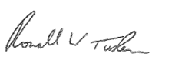 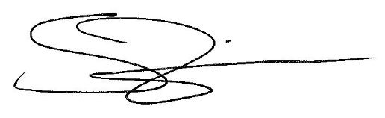

Rep. Ron Tusler Rep. Shannon Zimmerman

3rd Assembly District 30th Assembly District

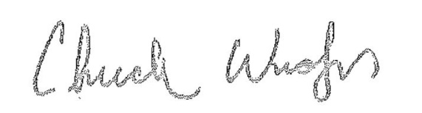

Rep. Chuck Wichgers   
83rd Assembly District