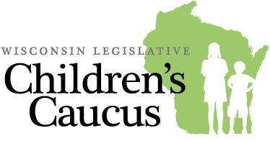

Call for Presentations
The Wisconsin Legislative Children’s Caucus is seeking presentations. The mission of the Children’s Caucus is to cultivate a legislature dedicated to advancing promising, evidence-informed public policy that improves the life of every Wisconsin child.

Please complete the following information and email your proposal to:
Kris Moelter, Policy Advisor
Child Abuse and Neglect Prevention Board
Kristinam.moelter@wisconsin.gov

Presentation format:
You may submit a proposal to give a 30-minute presentation to the Children’s Caucus at the State Capitol or you may submit a proposal to host Children’s Caucus members at your organization for an onsite event, such as an onsite tour of your program.

Check one:
Present at the State Capitol ☐
Event at your organization ☐ Location Click or tap here to enter text.
Presentation title: Click or tap here to enter text.
Presentation description (150 words or fewer): Click or tap here to enter text.
Describe how your presentation will advance promising, evidence-informed child and family public policy in Wisconsin (50 words or fewer): Click or tap here to enter text.
If you have presented this information within in the past year, please provide the date, location, event title and target audience. Also, please attach any materials that were provided during the presentation, including PowerPoint slides. Click or tap here to enter text.
Presenter name(s): Click or tap here to enter text.
Agency/Organization name: Click or tap here to enter text.
Email address: Click or tap here to enter text.
Telephone number: Click or tap here to enter text.

