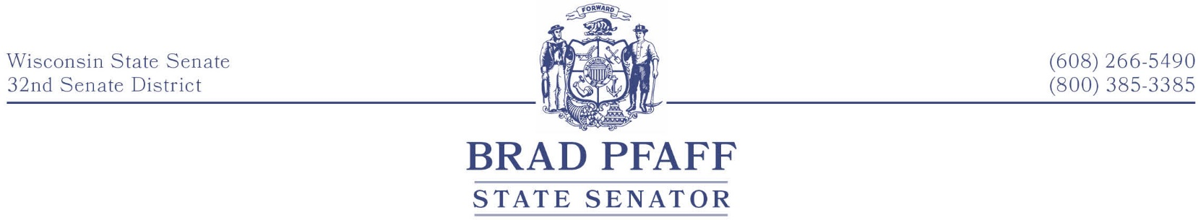
FOR IMMEDIATE RELEASE
December 17th, 2021
Contact: Senator Pfaff, (608) 266-5490

Investing in Farmers to Move Wisconsin Forward
  - A Year in Review
Wisconsin farmers feed the world. Consumers from around the globe enjoy agricultural products that are grown and harvested right here in our state. We must continue to invest in the tools that allow farmers and rural communities to succeed.
As the proud son of many generations of family farmers, I know how intertwined agriculture is with our state’s economy. That’s why this year, I introduced legislation to create new markets for farmers, attract new talent to the agriculture industry, and protect our land and water. “America’s Dairyland” is more than just a slogan on our license plate; it’s part of our state’s identity. It’s important that farmers have more opportunities to move their products locally and worldwide.
One of the essential duties of the State Legislature is deciding how we use our taxpayer dollars to invest in the things that matter most. This year, we made a down payment on rural Wisconsin’s future. I am proud to have voted to cut middle-class taxes by $2 billion, expand broadband to underserved areas, and invest money to fix our crumbling roads and bridges. High-speed internet, lower taxes, and better roads improve our quality of life and keep rural communities moving forward.
Growing up in rural La Crosse County, I learned an important lesson: we must work together to help our neighbors when times are tough. My goal for 2022 is to focus on what unites us instead of what divides us. Nobody has a monopoly on good ideas. By listening to one another, we have the opportunity to make headway on so many issues our families face. Incentivizing conservation will keep agricultural lands productive for years to come. Expanding BadgerCare will lower health care costs for rural residents. Decreasing the tax burden for farmers will make keeping the farm in the family easier. I will continue working across the aisle to turn these critical conversations into real results.
This year, we took steps toward bridging the urban-rural divide. Recognizing that what’s good for farmers is good for Wisconsin, we made significant investments in our dairy and meat industries, roads, and land stewardship. But, more needs to be done. I am confident that in 2022 we can continue working in a bipartisan manner to pave the way for our farmers and agriculture businesses to succeed.
###
Senator Brad Pfaff represents the 32nd Senate District, which includes La Crosse, Vernon, Crawford, and southern Monroe County. He previously served as Secretary-designee of the Wisconsin Department of Agriculture, Trade, and Consumer Protection (DATCP).

