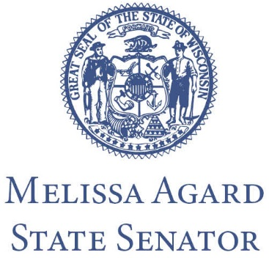

FOR IMMEDIATE RELEASE
Date: October 18, 2022
Contact: Senator Melissa Agard, 608-266-9170

Senator Agard Brings Awareness to the PFAS Firefighting Foam Collection and Disposal Program

MADISON – Yesterday, Governor Tony Evers and the Wisconsin Department of Natural Resources (DNR) announced the start of a PFAS-containing firefighting foam waste collection and disposal program. Senator Melissa Agard (D-Madison) released the following statement:

“Access to clean water is a human right, and in Wisconsin it is imperative that we have leadership that prioritizes this necessity for communities across Wisconsin. Simply put, water is life. I am grateful that Governor Evers and the Wisconsin DNR are working diligently to address PFAS contamination in our state. Wisconsin should be the gold standard for water quality. This is an important step to getting there.

“Governor Evers coined 2019 as ‘The Year of Clean Drinking Water,’ and created the Wisconsin PFAS Action Council (WisPAC) to develop a state action plan outlining a response to this harmful contaminant. Because of the recommendations of WisPAC, Governor Evers included a $1 million appropriation in the 2021-23 biennial budget to collect and dispose of PFAS-containing firefighting foam—the appropriation came to fruition this week.

“I have heard from many local leaders about the struggles they face with PFAS disposal, and this new program will undoubtedly provide needed assistance to communities throughout the state as they work to appropriately dispose of this harmful chemical. Fire departments interested in participating in the foam waste collection and disposal program may contact North Shore at info@nsecinc.com or (262) 255-4468.”

###

