STATE OF WISCONSIN

SENATE CHAIR  ALBERTA DARLING  317 East, State Capitol  P.O. Box 7882  Madison, WI 53707-7882  Phone: (608) 266-5830 | 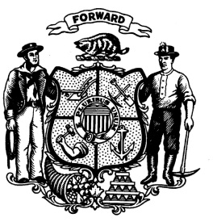 | ASSEMBLY CHAIR  JOHN NYGREN  309 East, State Capitol  P.O. Box 8953  Madison, WI 53708-8953  Phone: (608) 266-2343

JOINT COMMITTEE ON FINANCE

Notice of Agency Budget Briefings -- March 28, 29, and 30

The Joint Committee on Finance will meet in Room 412 East, State Capitol, to hold briefings by representatives of state agencies on the Governor's 2017-19 Biennial Budget -- Assembly Bill 64/Senate Bill 30 -- according to the schedule below. No public testimony will be taken at the briefings.

Tuesday, March 28 (9:00 a.m.)

• Department of Administration
-- Budget Overview
-- DOA Budget Provisions (including Building Commission and Budget Management and Compensation Reserves)
• Department of Employee Trust Funds (including self-insured group health plans)
• Elections Commission
• Supreme Court (including the Circuit Courts, Court of Appeals, Judicial Council, and Judicial Commission)
• Department of Corrections
• Department of Safety and Professional Services

Wednesday, March 29 (9:00 a.m.)

• Department of Justice
Department of Veteran Affairs
• Department of Health Services
• Department of Children and Families
• Department of Revenue (including Shared Revenue and Property Tax Relief and Lottery)
• Wisconsin Economic Development Corporation
• Department of Transportation

Thursday, March 30 (9:00 a.m.)

• Public Service Commission
• Department of Natural Resources
• Wisconsin Technical College System
• University of Wisconsin System
• Department of Public Instruction
• Historical Society
• Department of Workforce Development
• Labor and Industry Review Commission

___________________________ ___________________________
ALBERTA DARLING JOHN NYGREN
Senate Chair Assembly Chair

AD/JN/jm
cc: Members, Joint Committee on Finance

