What do you think about this issue? Click here and send an email with your thoughts.

Respectfully,

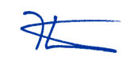
Kevin Petersen
State Representative
40th Assembly District

If you know anyone who would enjoy receiving updates on state issues, please have them contact me at rep.petersen@legis.wisconsin.gov to subscribe. If at any time you want to be removed from this list, simply send me an email asking to unsubscribe.

