Cultural Exchange

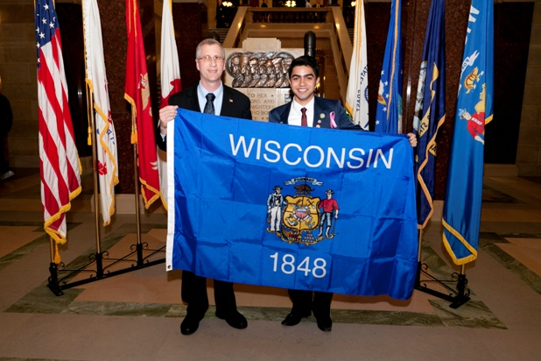

Representative Kevin Petersen presenting Wisconsin’s State Flag to Felipe Madruga – Clintonville Rotary youth exchange student from Brazil

On January 25th, I was honored to meet Felipe Madruga - a young man visiting America from Brazil as a participant in the Rotary Youth Exchange Program. I enjoyed sharing our state government’s traditions with Felipe, while at the same time learning about Brazilian government and culture.

