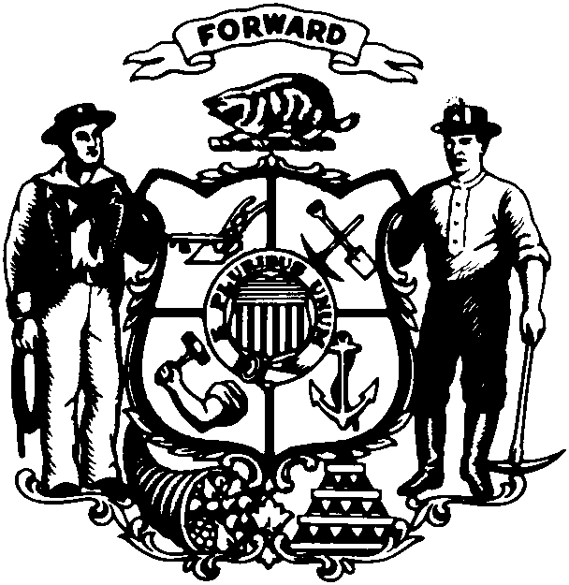

Robin J. Vos
State Representative • 63rd Assembly District • Racine County

FOR IMMEDIATE RELEASE

For Further Information Contact: February 1, 2011
Rep. Robin Vos
(608) 266-9171

REP. VOS VOWS TO IMPROVE STATE BUDGET WOES

MADISON...Rep. Robin Vos (R-Rochester) pledges his support to help fix the financial crisis facing the state as outlined in the Governor’s State of State address. The co-chair of the Joint Committee on Finance agrees it demands immediate attention.

“The former administration has left us in a financial mess that we now have to clean up. Basically, our credit cards are maxed out. We will end this spending spree and make the necessary cuts to live within our means,” said Rep. Vos.

Rep. Vos acknowledges the need for swift action to repair the state’s budget woes. He looks forward to working with the Governor on the budget and budget repair bills. “It’s time to make the difficult budget decisions because any delay will cost us much more in the long run,” said Rep. Vos.

The Republican-controlled legislature will continue to pass job creation initiatives during its “Open for Business” special session. Already, the Governor has signed 4 bills into law since taking office. The small business tax relief bill, which Rep. Vos authored, will be signed into law on Friday. The legislation gives tax deductions to businesses for each new job created.

“We are opening the doors to businesses to move to the state, providing tax relief to small businesses and putting an end to frivolous lawsuits,” said Rep. Vos. “We are putting our economy on the right track and we’re not done yet.”

###

