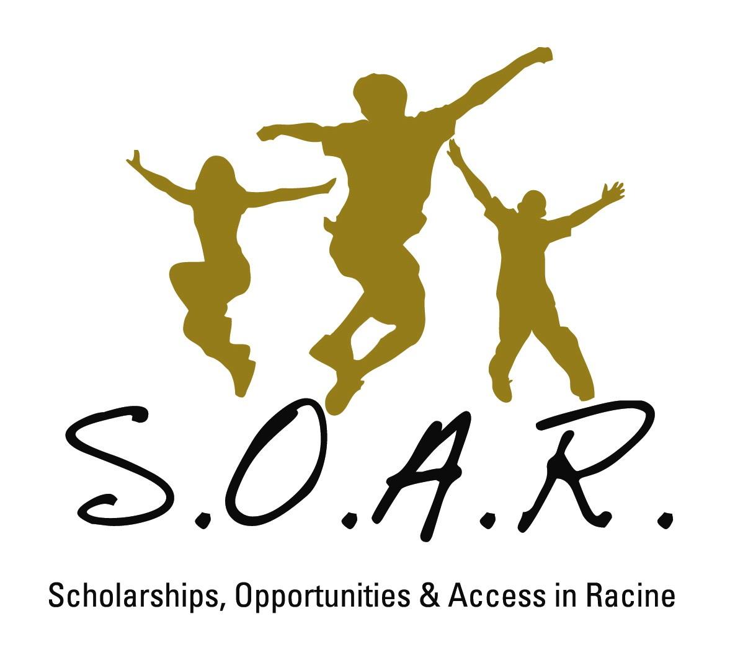
600-21st St.
P.O. Box 1782
Racine, Wisconsin 53401
262-498-9425
soarofracine@att.net
www.soarofracine.org

Contact:
Laura Sumner Coon
(262) 498-9425

Racine Schools Report on their first years in School Choice
Embargoed until April 14, 2013

Eight private schools participating in Racine’s Parental Private School Choice Program collaborated with SOAR of Racine and researchers from Mount Mary College to acquire a broader picture of the students and families they are serving in the new program. The group published their findings and information in a community report, “The Choice,” that will appear in Racine’s Journal Times on Sunday.
This is the second year Racine has a School Choice program. Legislation passed in 2011 extended the program to Racine, but capped participation the first year at 250 full-time equivalent students. In this second year, the program was capped at 500 full-time equivalent students.
Together, the eight schools collaborating in the report have the lion’s share of School Choice students in the Racine community – 386 of the 520 students in the program. SOAR and Mount Mary researchers collected data available for 363 of those students and conducted surveys of parents and students. Those findings are shared in the report.
Among them are the following:
- The average Racine family participating in the program at these eight schools has four people and lives on an adjusted gross income of $32,827;
- Minority students make up 56 percent of the School Choice students in these schools;
- More than half of the School Choice students in these schools live in families that earn less than $30,000 per year;
- More than half of the School Choice students in these schools are in the lower grades – 4-year-old Kindergarten through Grade 2 – and do not take standardized tests.
- One-hundred percent of the parents surveyed about School Choice said they are satisfied with the program;
- One-hundred percent of the parents surveyed said their children are learning and growing at their new school;
- Ninety-nine percent of the parents say they feel their child is successful at his/her school.

The eight schools participating in the report are: Concordia Lutheran School, Mount Pleasant Renaissance School, Our Lady of Grace Academy, Racine Lutheran High School, St. John’s Lutheran School, St. Joseph’s Catholic School, Shoreland Lutheran High School and Trinity Lutheran School.
The report accompanies this press release and is embargoed until Sunday, April 14. For more information, contact Laura Sumner Coon at (262) 498-9425.
#

