**JFC Public Hearings**

**Thursday, April 7th**

UW Stephens Point

Lee S. Dreyfus University Center

Stevens Point, WI

10 a.m.-5 p.m.

**Friday, April 8th**

Minong High School

Minong, WI

10 a.m.-5 p.m.

**Monday, April 11th**

Wisconsin State Fair Park

West Allis WI

10 a.m.-6 p.m.

**Wednesday, April 13th**

Arcadia High School

Arcadia, WI

10 a.m.-5 p.m.

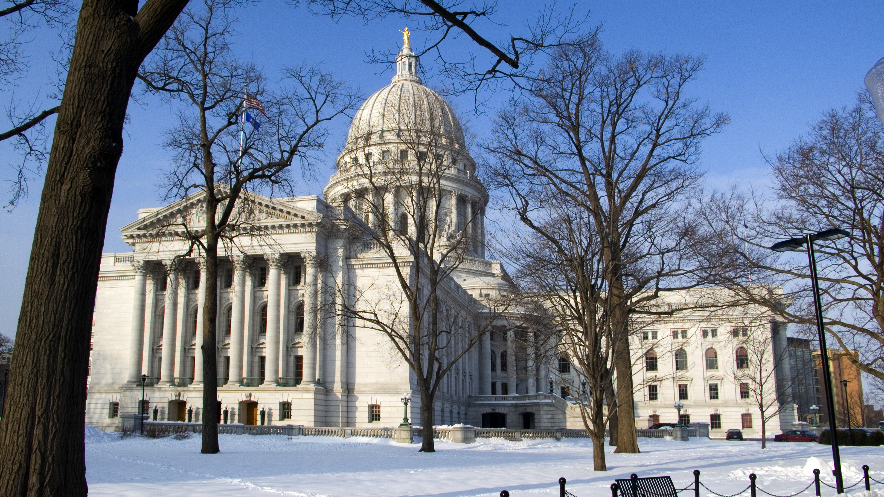

**March 25, 2011 Volume 1**

**Joint Committee on Finance**

**Announce Public Hearings**

Public hearings on the 2011-2012 Executive Budget begin in early April after several weeks of planning and coordination with the Legislative Fiscal Bureau. Much effort was put into the selection of the sites in order to give the committee a good cross-section of our population from rural to urban areas in different parts of the state. The locations were also chosen with regard to requests from our Democratic colleagues to have hearings in Milwaukee and northwestern Wisconsin.

The JFC members have a tight deadline to get the full legislature the budget due to the delay in the passing of the budget repair bill. Here is a link to a memo of the Legislative History of the Biennial Budget.  The JFC members have a very tight deadline to get the full legislature the budget. Committee members want enough time to be briefed and get input from the public and from our fellow legislators in order to put together a final budget plan.

The public hearings are not the only means for citizens to communicate their opinions. This new e-mail address, [budgetcomments@legis.wisconsin.gov](mailto:budgetcomments@legis.wisconsin.gov) has been created to allow citizens to address the committee who may not have a chance to attend the hearings. The public is also encouraged to continue to reach out to their own legislators on issues that are important to them.