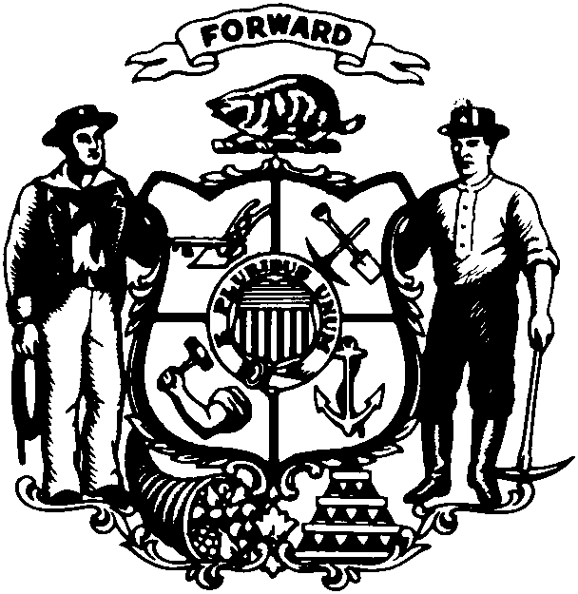

Robin J. Vos
State Representative • 63rd Assembly District • Racine County

FOR IMMEDIATE RELEASE

For Further Information Contact: February 11, 2011
Rep. Robin Vos
(608) 266-9171

REP. VOS: STATEMENT ON BUDGET REPAIR BILL

MADISON...Rep. Robin Vos (R-Rochester) released the following statement about Governor Walker’s proposed budget repair bill.

“The days of spending more money than we have is over. It is time to make the difficult decisions. Simply, we need to pay our bills for this budget cycle before we can map out the spending plan for the next one.”

“The gimmicks, accounting tricks and tax increases from the former administration have only dug us deeper into debt. We now have to go about reducing the deficit the old fashioned way: cut spending.”

“Every single public employee has a valued job, no question, but everyone, from major employers to small businesses, is being asked to do more with less. State governments around the country are no different. I believe it’s a reasonable expectation to ask public employees to contribute more to their pensions and health care, comparable to the private sector.”

“This budget repair bill will give local communities the necessary tools to help them balance their own budgets while giving public employees the freedom they deserve.”

“I support Governor Walker’s proposed budget repair bill and look forward to working with lawmakers to get it passed.”

###

