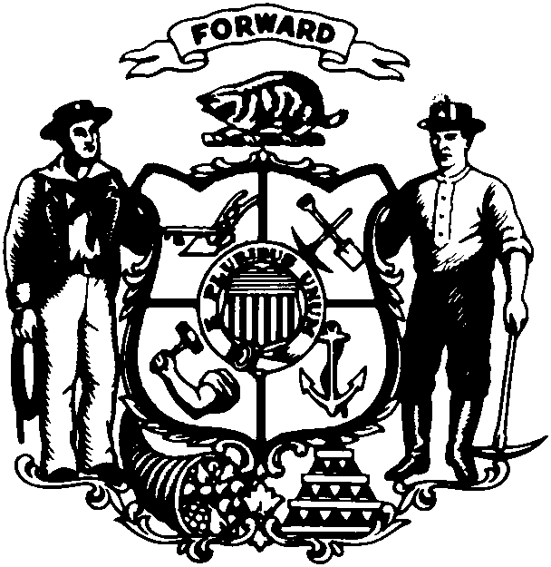

Robin J. Vos
State Representative • 63rd Assembly District • Racine County

FOR IMMEDIATE RELEASE

For Further Information Contact: March 10, 2011
Rep. Robin Vos
(608) 266-9171

REP. VOS: STATEMENT ON FINAL PASSAGE OF BUDGET REPAIR BILL

MADISON...Rep. Robin Vos (R-Rochester) released the following statement about the final passage of the budget repair bill.

“Today’s vote is a victory for Wisconsin. We are finally making the tough decisions to balance the state’s budget and put an end to our fiscal crisis. This legislation will help put our economy back on the right track and bring new jobs to the state. We were elected to hold the line on taxes and make sound fiscal decisions.”

“Without question, today’s vote was done within the letter of the law. We spent 17 hours listening to public testimony and more than 64 hours of debate on the Assembly floor. The Republican leadership made every effort to find common ground, however the 14 A.W.O.L. Senate Democrats seemed to have made the choice to never return to Madison for a vote.”

“As we begin to discuss the Governor’s biennial budget plan in the next few weeks, we must now move forward to continue our efforts to put the state’s fiscal house back in order.”

###

