Testimony in Support of Uniform Antifreeze Bittering Agent Legislation –
House Bill 398

Pam McCloud Smith
Executive Director
Dane County Humane Society
Madison, WI
March 5, 2010

On behalf of Dane County Humane Society (DCHS), I present our support for uniform antifreeze bittering agent legislation in Wisconsin; as contained in House Bill 398.

Thousands of animals (companion animals, birds, and other wild and endangered species) are accidentally poisoned each year by ingesting antifreeze left exposed in leaks and spills, or improperly stored or disposed of. Antifreeze (ethylene glycol) emits a sweet, attracting odor/taste likened to Kool-Aid. One survey estimates 10,000 dogs and cats nationally are poisoned by ingesting spilled antifreeze each year. Another survey suggests the number could be as high as 90,000. The American Veterinary Medical Association (AVMA) and The Pet Food Institute, among many other groups, recommend that a bittering agent be added to antifreeze to help prevent consumption.

The uniform bittering agent legislation this bill is modeled on requires that engine coolant/antifreeze which is more than 10 percent ethylene glycol must also contain denatonium benzoate, the world’s bitterest known substance, to render it unpalatable. This legislation can be a useful tool in helping avoid injury and death for countless domestic and wild animals.
Ten states— Arizona, California, Maine, New Mexico, New Jersey, Oregon, Tennessee, Vermont, Virginia, and Washington as well as British Columbia — have successfully passed similar legislation requiring a bittering agent be added to ethylene glycol antifreeze to make it unpalatable.

Dane County Humane Society supports the uniform antifreeze bittering agent legislation – House Bill 398

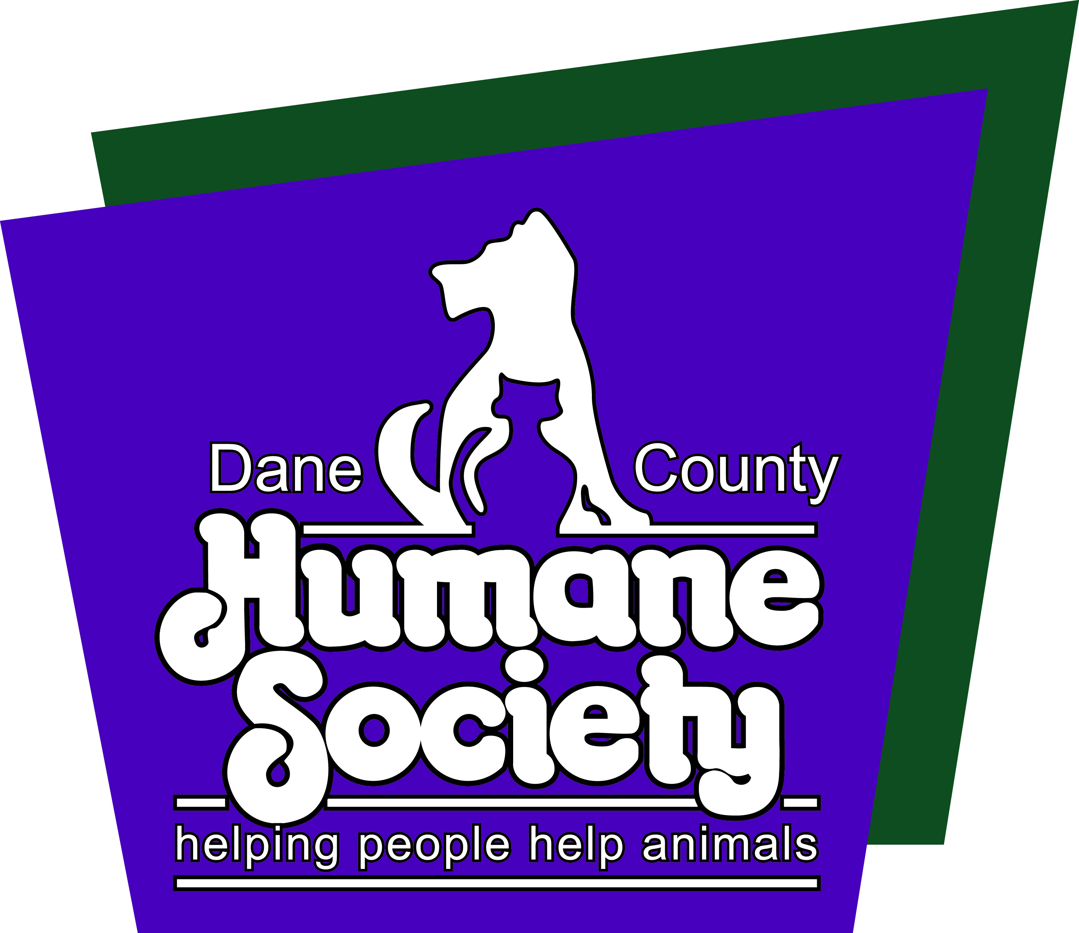

About Dane County Humane Society
Dane County Humane Society (DCHS) is located at 5132 Voges Road in Madison, Wisconsin. Established in 1921, DCHS has a solid history of serving both the people and animals of the community. The current shelter was built in 2000. DCHS owns 29 acres of land around the building that is utilized for dog walking and a wildlife rehabilitation center. There is a barn and paddock that includes three stalls available for caring for horses and livestock.

