March 31, 2010

Members of the Assembly Judiciary and Ethics Committee
Madison, WI

Re: Assembly Bill 815

Dear Members of the Assembly Judiciary and Ethics Committee:

The National Insurance Crime Bureau (NICB) is a national, not-for-profit organization supported by approximately 1,000 property/casualty insurance companies, including many who write business in Wisconsin. Working with our member companies and law enforcement, we investigate organized criminal conspiracies dealing with insurance fraud and vehicle theft.

We are writing to express our opposition to Assembly Bill 815 pending in the Wisconsin State Legislature.

An analysis of questionable claim referrals to NICB indicates an increase in Wisconsin reports related to medical and workers compensation fraud. Specific problem areas include collusion between medical providers and runners, slip and fall incidents, upcoding, etc. In fact, from 2007 to 2009, suspected fraud referrals increased by over 30% in Wisconsin.

Our specific objection to the proposed language within Wisconsin Assembly Bill 815 pertains to Section 804.10 (2m). We fear this raised threshold for discovery pertaining to preexisting conditions or previous incidents could have a negative impact on the detection of fraud-related activity. The requirement within the proposed legislation could substantially hinder access to information tangible to a fraud investigation. Access to such records is of utmost importance in the investigation of insurance fraud.

As the insurance industry’s focal point for insurance fraud prevention and detection, NICB has first-hand knowledge of multi-claim, multi-carrier fraud investigations. We oppose this language as a potential obstacle in efficiently rooting out insurance fraud in Wisconsin.

If you have any questions, please feel free to contact me directly at (847)544-7080 or via email at tlynch@nicb.org.

Sincerely,

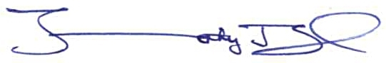
Tim Lynch
Director, Government Affairs

cc: Andrew Franken, Wisconsin Insurance Alliance

