
Wisconsin
1 W. Wilson, Room 851
PO Box 7851
Madison, WI 53707-7851
Voice: 608-266-2712
Fax: 608-267-7793

Council on Mental Health

March 30, 2010

To: Wisconsin State Representatives

Dear Representatives:

The Wisconsin Council on Mental Health (WCMH) would like to take this opportunity to express strong support for Assembly Bill 681, relating to orders to commit inmates of prisons to mental health treatment.

The proposed bill under the alternative petition would allow an inmate of a prison to be initially committed for treatment for a period not to exceed six months, and any consecutive commitment orders may not exceed 12 months. This change in length of time for prison inmates would align the initial and consecutive commitment timeframes with the timeframes of the non-prison populations.

Under current law, the commitment procedure for an inmate in a prison under an alternative petition, if substantiated allows a commitment for treatment of not more than 180 days in a
365-day period. For the remaining six months an individual will go untreated unless the individual voluntarily agrees to treatment. Some individuals simply do not recognize their illness and their dangerousness and need involuntary treatment. Some of the disadvantages of leaving a mentally ill individual untreated are related to the potential for harm to the individual or to others and the list below is not inclusive:
- Danger of self inflicted harm.
- The safety of staff could be affected.
- The inmate could be prosecuted for hurting someone while decompensating from mental illness.
- An untreated individual with mental illness is subject to abuse when acting out his/her illness in the prison environment, both from peers and staff.
- Each time a mentally ill individual decompensates after being taken off the medication; this “on again/off again” with medication causes issues stabilizing the individual and may make it more challenging for the individual to return to baseline functioning.
- The inmate off medication can be very uncomfortable and staff are required to control the environment in order to protect the individual-which can be de-humanizing i.e. toilet in the floor, special clothing, isolation, etc.
- An individual decompensating from their mental illness could be released into the community putting the general population at risk. Throughout the state there are long wait lists for services-may lead to plenty of time to re-offend.

AB681 would correct this oversight by allowing Corrections personnel an avenue to seek involuntary treatment when an individual is not able to recognize their need and to ensure health and safety needs or inmates.

The Wisconsin Council on Mental Health recognizes the needs of individuals with severe mental health needs in our prisons and encourages you to vote in support of these bills as it will establish a similar process for involuntary treatment throughout the state regardless of individual and their behaviors or offenses. It will also lead to better treatment options and outcomes for inmates and perhaps lead to better integration into the community upon release and reduce recidivism.

We urge you to vote in favor of these bills.

If you have any questions, please contact me at (715) 605-2097 or by e-mail at jackiebaldwin@verizon.net.

Sincerely,
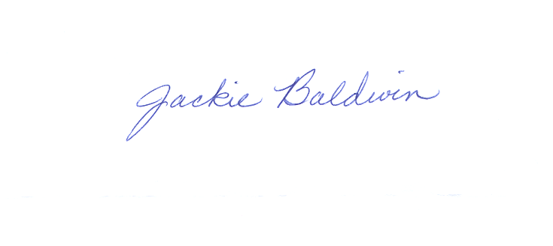

Jackie Baldwin, Chair
Wisconsin Council on Mental Health

cc: Members, Wisconsin Council on Mental Health
Members, Mental Health Council Criminal Justice Committee
John Easterday, Administrator, Division of Mental Health and Substance Abuse Services
Joyce Allen, Director, Bureau of Prevention Treatment and Recovery
Melanie Foxcroft, Council Staff

