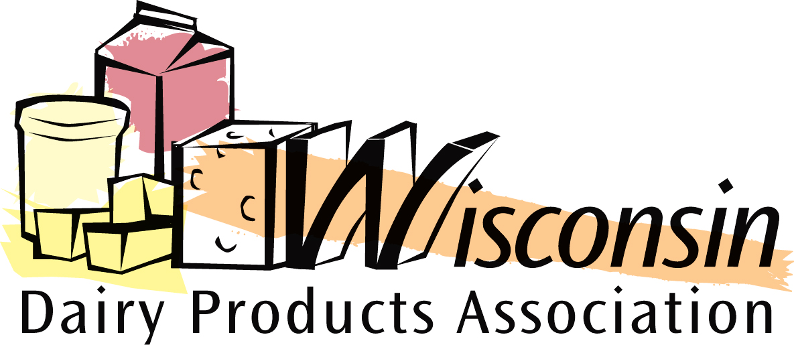

To: Members of the Wisconsin Assembly
From: Brad Legreid, Executive Director, Wisconsin Dairy Products Association
Date: 4/19/10
Re: Raw Milk Bills AB 628/SB 434

On behalf of the members of the Wisconsin Dairy Products Association (WDPA), I respectfully request that you do not vote in favor of AB 628 or SB 434 if they are scheduled for a floor vote.

WDPA member companies, who market approximately 70% of the dairy products in Wisconsin, strongly oppose this legislation for the following reasons:

- Raw Milk is unhealthy to consume. Every major health organization in the world has stated its strong opposition to raw milk. Almost weekly, a new incident of people getting sick from ingesting raw milk pops up in the U.S. According to the Center For Disease Control, more than 1500 people became ill from drinking raw milk from 1993-2006. Just in the past year, there have been almost 100 sicknesses due to raw milk in 7 different states.
- A major outbreak of sickness from raw milk could do irreparable harm to Wisconsin’s dairy industry. This industry is the #1 industry in Wisconsin. Tens of thousands of people depend on it for their livelihoods. Especially in these tough economic times, legislation should not be passed that has the potential to cause catastrophic damage to our leading industry. There are many other past cases where an industry has been ruined due to the public getting sick from consuming contaminated products (i.e. peanut, tomato, pistachio industries, etc.). Even though these past contamination cases may have only been a few isolated incidents, the general public associates the contaminated product with the entire industry which causes a blanket condemnation. There is a small minority of people who wish to consume raw milk and want the freedom of choice. But, we cannot let this small minority jeopardize the livelihoods of our state’s 13,000 producers, plus the thousands of other individuals and companies involved in the dairy industry.
- There are no additional health benefits to raw milk that are not already found in pasteurized milk. No major/reputable health organization has ever found any added health benefits in raw milk. On the contrary, raw milk can contain a variety of bacteria, which can cause major illnesses in people- especially the young, old, and those with weakened immune systems.

These are just three major reasons for opposing the bills. Please do not vote for SB 434 or AB 628. Please allow the recently-formed DATCP advisory committee to carefully and prudently review the raw milk issue. This committee is extremely well balanced with an equal number of proponents and opponents. This committee will be meeting through this summer and will issue its conclusions in the fall. The legislature can than review these findings and determine what the appropriate course of action is for raw milk.

Thank you for your consideration.

