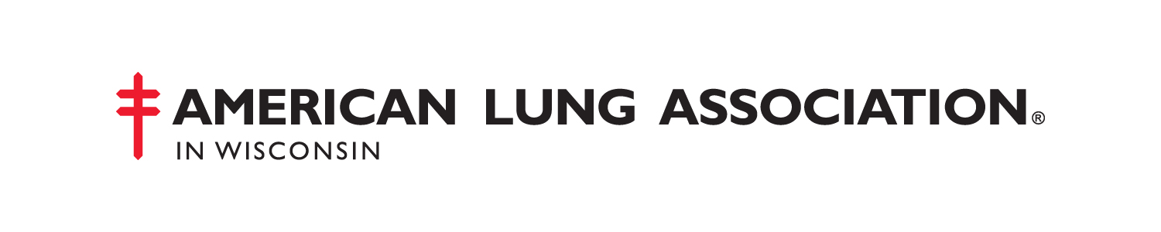
LEADERSHIP BOARD
Steven T Mielke
Chair

Todd A Mahr, MD
Vice Chair

Michael J Jaeger, MD
Secretary

Nancy K Korom, RN, MSN
Immediate Past Chair

Robert J Berdan
Eric P Christophersen
Lori A Craig
James W Ehrenstrom
John F Emanuel
Caroline V Krider
Kim E Lacina
Thomas P Luljak
Linda L Newberry-Ferguson
Michael J Redding
Rodney D Reider
Penny J Siewert
Ricardo J Soto, PhD

EXECUTIVE DIRECTOR
Susan Gloede Swan

SENIOR COUNCIL
John P Gwin
Charles E Reevs
John E Stevenson, MD
David L Vollmar

13100 West Lisbon Road
Suite 700
Brookfield, WI 53005-2508
phone: 262-703-4200
fax: 262-781-5180

800-LUNG-USA
www.LungWI.org

Fighting for Air

October 26, 2009

Honorable members of the Wisconsin Assembly:

Please support AB408, the Renewable Fuels bill that was recently voted out of the Committee on Renewable Energy and Rural Affairs.

This legislation is the result of many months of close study by a wide range of experts, and we believe their recommendations are sound.

The American Lung Association in Wisconsin supports the legislation because it will increase the availability and use of E85, a motor vehicle fuel that consists of 85 percent ethanol and 15 percent traditional gasoline. E85 is an official Clean Air Choice® of the American Lung Association of the Upper Midwest because it reduces harmful tailpipe and evaporative emissions that contribute to air pollution, and as such, increase and/or exacerbate lung disease.

E85 reduces ozone forming pollutants (nitrogen oxides and volatile organic compounds) and particle pollution by 20 percent each, evaporative emissions by 25 percent and greenhouse gases by 30 percent. In fact, a typical flex fuel vehicle (FFV) driver can prevent four tons of lifecycle CO2 and other pollutants from entering our air every year simply by fueling with E85 instead of gasoline. Gasoline also contains compounds such as benzene, toluene and xylene which are extremely harmful to human health.

The recent redesignations of several Wisconsin counties for ozone and particle pollution further underscore the need to reduce these and other air pollutants that contribute to lung disease. E85 is a valuable tool in achieving that goal and will play an important role in the revised air quality State Implementation Plans, required by the federal government.

The bill does not mandate the use of E85 or any other renewable fuel, but makes it a more readily available choice for all Wisconsin consumers.

On behalf of the estimated 739,000 Wisconsin men, women and children who suffer from lung disease, I strongly encourage you to support AB408.

Please don’t hesitate to contact me if you have any questions.

Thank you for your valuable assistance as we continue our second century of Fighting For Air.

Sincerely,
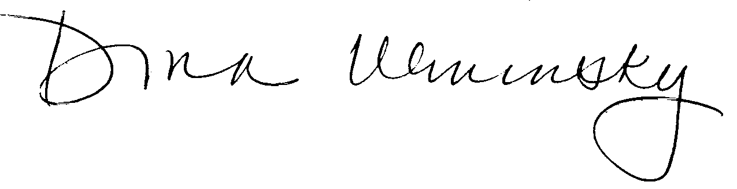
Dona Wininsky
Director of Public Policy and Communications
American Lung Association in Wisconsin

Please remember the American Lung Association in your will and trust.

