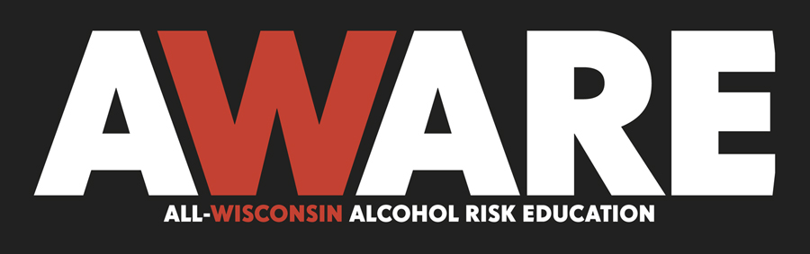
AWARE Coalition Members
Affinity Health System
Aurora Health Care
Bay Area Community Council
Beloit Memorial Hospital
BRAVO is Building Responsible Alcohol Values and Options
Children’s Hospital and Health System
Columbia County Connects
Dane County
Dane County Medical Society
Edgerton Coalition for a Health Community
Focus on Community, Racine
Froedtert & Community Health
Gundersen Lutheran
Healthy Sheboygan Co. 2020 AODA Comm.
Horizon High School, Dane County
KEYS is Keeping Everyone You Know Safe
La Crosse County Board of Supervisors
Madison Mayor’s Office
Marathon Cty. Alcohol & Other Drugs Partnership Council
Marathon County Health Department
Marshfield Clinic
Medical College of Wisconsin
Medical Students for Legislative Action
Meriter Health Services
Milwaukee Deputy Sheriffs Association
Ministry Health Care
Mothers Against Drunk Driving
Ntl. Assoc. of Alcoholism & Drug Abuse Counselors
Reedsburg Area Medical Center
Resource Center on Impaired Driving
Rock County Partners in Prevention
Rock County Youth2Youth
Rogers Behavioral Health System
Rural Wisconsin Health Cooperative
St. Croix Valley Restorative Justice Program
St. Joseph’s Community Health Services, Hillsboro
Southern Alliance Regional Council (SARC)
Tobacco & Drug Free Communities of Winnebago County Coalition
Unity Health Insurance
UW Health
Vernon County Partnership Council
Watertown Parent Advisory on Underage Drinking
WI Alcohol & Drug Treatment Providers Assoc.
WI Assoc. of Local Health Departments and Boards
WI Assoc. on Alcohol & Other Drug Abuse
WI Assoc. of Alcoholism & Drug Abuse Counselors
WI Chapter of the American College of Emergency Physc.
WI County Police Association
WI District Attorneys Association
WI Hospital Association
WI Medical Society
WI Nurses Association
WI Prevention Network
WI Public Health Association
WI Public Health Council
WI Sheriffs & Deputy Sheriffs Association
WI State Laboratory of Hygiene
WPS Health Insurance

TO: MEMBERS OF THE STATE ASSEMBLY
FROM: LISA MARONEY, UW HEALTH 265-1653
DATE: APRIL 15, 2010
RE: SUPPORT AB 106

We urge your support of Assembly Bill 106 authored by Representative Kim Hixson establishing a minimum age of 18 for minors to be able to drink with their parent or guardian in a tavern or restaurant. Please note the following facts:

- WI Leads the country with the highest U.S. rates of alcohol consumption, binge drinking and heavy drinking.
- Highest alcohol use in the country among high school students.
- WI drunk driving fatalities have actually increased when nationwide fatalities have decreased.
- It is estimated that over half of Wisconsin’s prison population have AODA issues.
- Underage alcohol consumption can have profound effects on adolescent brain development.
- WI and Texas are the only two states that permit guardians/parents to purchase alcoholic beverages in a tavern or restaurant for their children of any age.

The Tavern League of Wisconsin on the GAB web site has registered in support. We are not aware of any organizations or groups opposed to the bill.

Dr. Patricia Kokotailo, director of adolescent medicine and associate dean for faculty development and faculty affairs at the University of Wisconsin School of Medicine and Public Health, is the lead author of a new policy statement released this month by the Committee on Substance Abuse for the American Academy of Pediatrics.

The policy statement cites research that concludes the younger people are when they start drinking, the more likely they are to have significant problems in their lifetimes, including abuse and addiction.

“A remarkable amount of brain development is still occurring for young people through their twenties,” Kokotailo says. “The parts of the maturing brain most impacted by drinking are essential for developing organizational skills, emotional regulation, abstract thinking, and impulse control.”

We urge you to pass AB 106 to address an important public health issue. Thank you.

