
April 26, 2009
Hartland/Lakeside School District
800 North Shore Drive
Hartland, WI 53029

Dear Legislators:

In response to the consideration that prep-time becomes a mandatory subject of bargaining I would like you to highly consider the children we are educating before you take this action. Proponents of this legislation will argue that teacher preparation will assist them in doing their job more efficiently and effectively. Research does not support this. Staff development that is highly focused, organized, and consistent does demonstrate direct improvement for student learning.

As a superintendent and educator, I support teacher planning and more importantly teacher professional growth. However, the extent and need for these activities need to be conducted at the district level. Like many other restrictive policies, Assembly Bill 95 will put teachers before children and could result in other services being reduced. More importantly, with shrinking budgets and the reluctance to raise taxes, this legislation will further restrict the education of our children.

I am asking you to greatly reconsider this Bill. Please keep this decision within the realm of our school boards and community. By agreeing to this, the interest of our children will most certainly be left out. Here’s an example:

Due to budget reductions that require a board to reduce some programming the union would argue loss of prep time. The district then may be forced to reduce other areas of support that are more essential to students, but do not affect prep time. Also, the district may raise class size, causing a negative impact on learning. In addition, the district may be forced to eliminate a position that provides prep-time, but now will put students in study halls, or under the direction of a teacher assistant, further depleting needed quality instruction.

Our district strongly supports teacher prep-time and professional development. We have one of the most progressive teacher staff development programs in the state. But taking away MORE decision-making authority from our school boards and parents will further erode our educational system.

Support for Assembly Bill 95 will be communicated to school boards and parents as an example of how our legislators are putting special interest ahead of the needs of our children. I implore you not to approve Assembly Bill 95.

Sincerely,
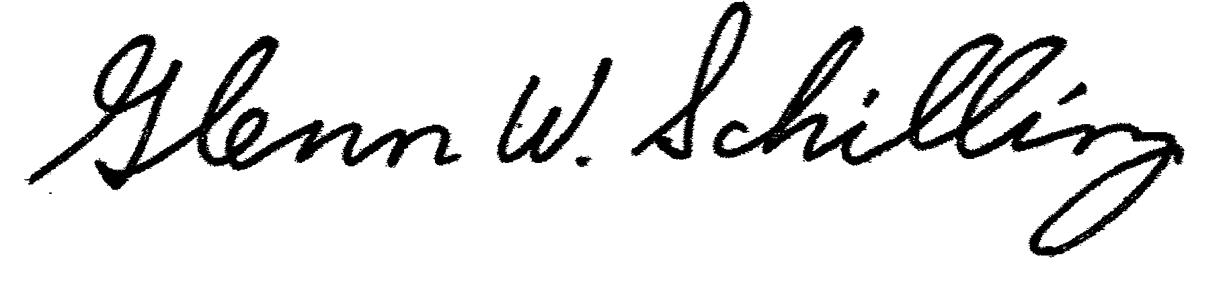

Glenn W. Schilling, Ph.D.
Superintendent

