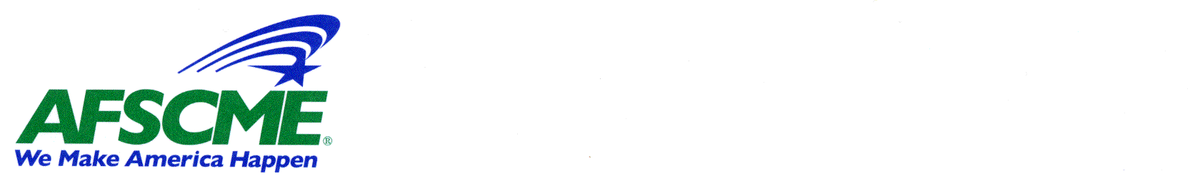

Monday, March 23, 2009

To: Members, Wisconsin State Senate

From: Marty Beil, AFSCME Council 24 (Wisconsin State Employees Union)
Susan McMurray, AFSCME Council 11

Re: AFSCME on SB 51/AB 78, fixing Wisconsin’s John Doe law

Reforming the John Doe law is a top priority for AFSCME and especially for our members who work in state or county correctional settings. SB 51/ AB 78 safeguard the right of law-abiding citizens to have the full access to the courts that they expect and deserve. The bills also recognize that changes are needed to make it harder for individuals to abuse the law by filing frivolous claims against public employees.

Current law has been exploited by convicted criminals, forcing corrections staff to mount costly defenses against bogus claims, even after investigations by the Department of Corrections and the local District Attorney have shown these claims to be baseless. The bill before the committee was prompted after a Dodge County judge filed felony charges against a Waupun Correctional Officer in 2007. The judge issued charges based solely on the word of the inmate. The judge argued that the John Doe statute and case law interpretations prohibited him from considering the full scope of evidence and testimony of witnesses. The case pointed to a flaw in the law that must be addressed to protect everyone from frivolous John Doe complaints.

Last session, AFSCME worked with legislators to try to fix the John Doe statute and varying approaches evolved. This year, we have forged a new approach that has bipartisan support. It is backed by members of our union who work in correctional settings across Wisconsin.

SB 51 protects against frivolous John Doe claims in several ways:

1. It requires that judges refer all John Doe complaints to district attorneys for review before the judge may act on them. This is not required under current law. Inmates have found that they can bypass the scrutiny of D.A.s and force judges to initiate proceedings, regardless of evidence.

2. It requires D.A.s to look into complaints and issue written recommendations to judges within 90 days on whether or not charges should be filed.

3. It allows judges to consider evidence and the testimony of witnesses in any John Doe case that comes before her or him.

4. It requires judges to consider all evidence and the testimony of witnesses before felony charges may be filed. This creates a higher threshold for judges to meet and is a key reason why AFSCME supports the bill.

5. SB 51 provides for payment of legal fees for state employees who face felony charges and who are later cleared. The language specifying that legal fees shall be paid under these circumstances sends a clear and strong message to those who might be tempted to use the law to harass public employees who are merely doing their jobs.

We don’t know exactly how many public employees have been the subjects of John Doe complaints largely because of the secret nature of the process. We do know that officers at Columbia Correctional Institution, Green Bay Correctional Institution, the Wisconsin Secure Program Facility (formerly known as Supermax) and the New Lisbon Correctional Institution have been the subjects of John Doe investigations. In addition, state probation and parole agents have been targeted by disgruntled clients, as have our members at the Wisconsin Resource Center (a DHS facility). No charges have been filed in any of those other cases to date.

The John Doe statute must be fixed to discourage frivolous complaints from being filed against public employees who are merely carrying out the duties of their job. While corrections workers have been the target of these complaints so far, it won’t be long before we start seeing complaints filed against public inspectors, health care workers, child support enforcement staff, child welfare workers or others, given the nature of the work that public sector employees perform.

SB 51/AB 78 strike an ideal balance between respecting the rights of people to have full access to the courts and setting up the proper checks and balances to prevent frivolous complaints against public employees and all citizens.

AFSCME asks members of the Senate to pass SB 51 as it is written, with no amendments. Please contact Marty at 608-836-0024 or Susan at 608-279-9697 with concerns or questions.

Thank you for considering this important legislation.

