
E-Update – April 15, 2011
A Successful First 100 Days in the State Legislature

Remarkably, last Tuesday was the 100th day of the legislative session. The hard work of my colleagues and I in Madison is already paying off.

In this short time we have passed a number of innovative and pro-active measures that have resulted in thousands of new jobs across Wisconsin and a decline in the state’s unemployment rate.

These measures include a package of bills made up of tax incentives for businesses that relocate to Wisconsin and create jobs, tax relief for small businesses, and an improved Department of Commerce whose main goal is job creation.

On Tuesday, we marked our 100th day in office by passing additional jobs bills that will help us continue our economic turnaround and put even more people back to work by passing the “Rural Jobs Act.”

Despite these great successes, we are not done yet.

Voters sent us a clear message in November that we need jobs, jobs and more jobs. We have and will continue to address this issue decisively and quickly. Another clear message was to keep our taxes down.

The proposed 2011-13 State Budget keeps our taxes down by not including ANY tax or fee increases. This budget also makes a lot of tough but necessary decisions that I can support including not raiding segregated funds, cutting government spending, and reducing the projected structural deficit to the lowest in over 10 years. There are many areas that still need improvement and I welcome your feedback and constructive ideas as the budget is being debated and amended.

In the weeks and months ahead, I will continue to push to get Wisconsin working again. If our first 100 days in office are any indication of what lies ahead, it is going to be an exciting and successful summer in Wisconsin.

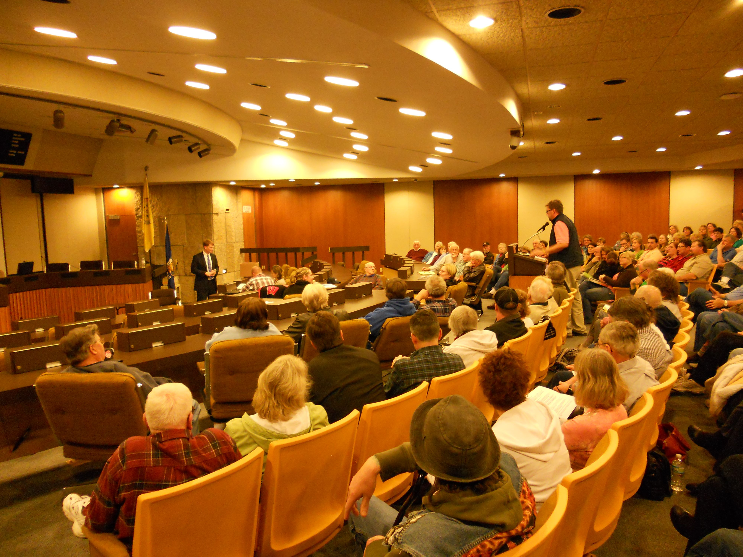
Rep. Thiesfeldt hosted about 200 individuals during the Monday, April 11 listening session.
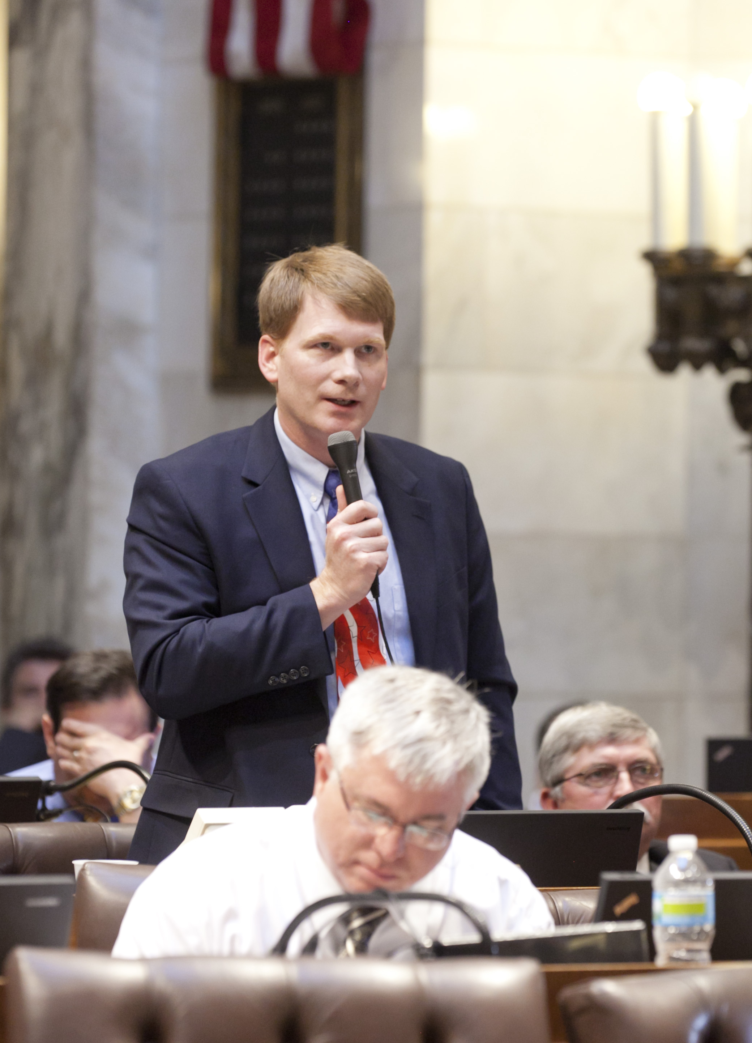

Rep. Thiesfeldt gives his first floor speech on Tuesday, April 12, 2011

Quote of the Day

“The problem is not that people are taxed too little, the problem is that government spends too much.” – Ronald Reagan

Interesting Wisconsin Fact
There are approximately 1,634 farms that cover more than 344,266 acres of land (2002 Ag Census) in Fond du Lac county. The average farm size is about 210 acres. Among Wisconsin counties, Fond du Lac ranks fifth for total milk production and sixth for the number of dairy cows (2007 Wisconsin Ag Statistics Service).
Office Statistics: My office has responded to 1807 constituent concerns, inquires, position statements, and ideas.
Contact Information:
Email: Rep.Thiesfeldt@legis.wi.gov

US Mail: Rep. Jeremy Thiesfeldt
PO Box 8953
Madison, WI 53708

Telephone: (888) 529-0052 (toll free)
(608) 266-3156

Please provide your address and phone number when you contact me. It is appreciated.

If you prefer not to receive my newsletters simply email me at Rep.Thiesfeldt@legis.wi.gov with the subject line "unsubscribe" and I will be happy to remove your address from my list.
Or click here to send an email to unsubscribe to this newsletter.

