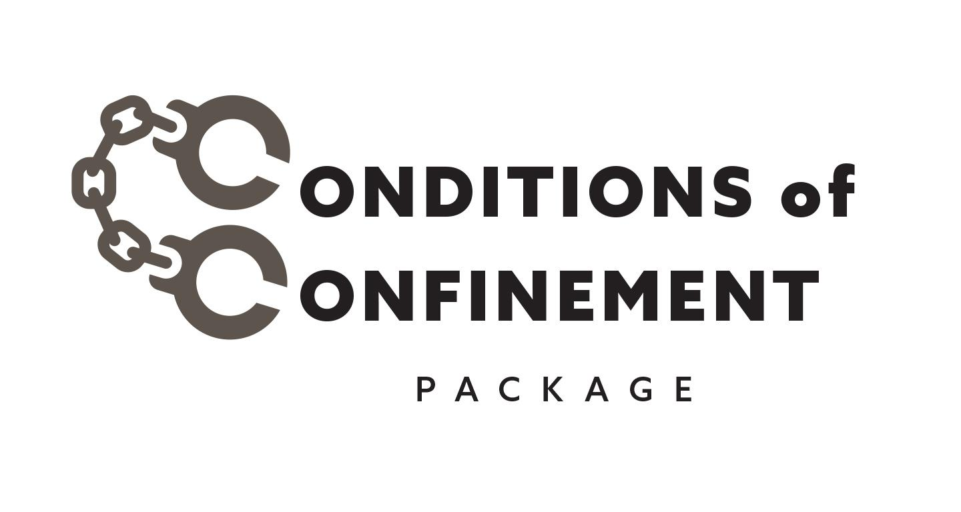
FOR IMMEDIATE RELEASE
November 2, 2023
Contact: Rep. Ryan Clancy, (608) 237-9119

Legislative Democrats and Coalition of Stakeholders introduce a Conditions of Confinement Bill Package

MADISON, Wis - Today, a coalition of Legislative Democrats and stakeholders held a press event to introduce legislation to improve conditions of confinement in the State of Wisconsin. Speakers included directly impacted residents and representatives from WISDOM, EX-incarcerated People Organizing of Wisconsin (EXPO-WI) and the Wisconsin American Civil Liberties Union (WI ACLU). The package includes 17 bills and will address the conditions of confinement in county and state correctional institutions.

The legislative authors of the Conditions of Confinement package released the following statement:

“From lockdowns to deaths in custody and protests, current prison conditions are at a breaking point. Today, we introduced legislation to address the unacceptable conditions for people in our custody across the state of Wisconsin.We know that a vast majority of people who are currently incarcerated will return to our communities. We owe it to those individuals and our communities to maintain correctional facilities that are humanely run and promote rehabilitation in an environment of basic dignity and respect.

“We are grateful to every person who shared their lived experience helping us to create this package, from folks who were formerly incarcerated to correctional officers and DOC leadership. We are hopeful that this legislation will move forward with bipartisan support in the coming weeks.”

Please see the bill explainer for full details of the package.

###

