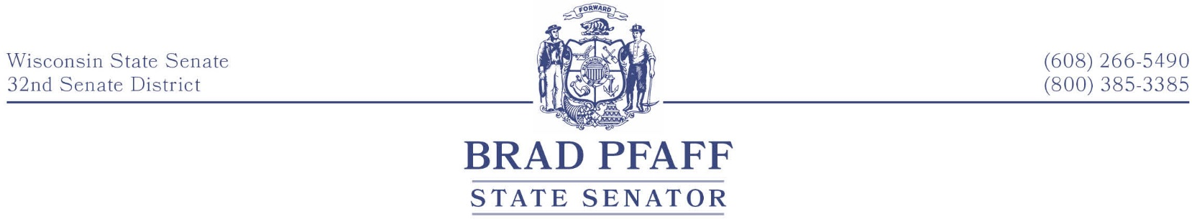
FOR IMMEDIATE RELEASE
December 16th, 2021
Contact: Senator Pfaff, (608) 266-5490

Working Together to Get Wisconsin Working
  - A Year in Review
As the calendar turns from 2021 to 2022, I want to take a moment and reflect on some of the important work we’re doing to help unite our communities and ignite our economy.
The budget we passed earlier this year invests in our future. I am proud to have voted for more than $2 billion in middle-class tax cuts, the most significant broadband expansion effort in state history, and $100 million in funding to fix our roads. High-speed internet, lower taxes, and better roads improve our quality of life and keep communities moving forward. Although we didn’t get everything our state needs from the budget, I have kept my promise to work hard and fill in the gaps by introducing new legislation.
Wisconsinites believe in a hard day’s work for an honest day’s pay. That’s what makes our Main Street businesses the bedrock of our economy. I think that these businesses should keep more of the money they earn. That’s why I introduced a bill to eliminate the burdensome Personal Property Tax in Wisconsin once and for all. For years, this has been a bipartisan goal, and I’m ready to get it done. We also need to start building things again in this state. Improving our roads, bridges, and buildings gives us pride and creates family-supporting jobs. My “Buy American” bill package would ensure that our state government promotes American and Wisconsin jobs by prioritizing buying products made right here.
Our children are our future. Regardless of the zip code that a child may live, they deserve access to a high-quality public education. I was proud to support initiatives this year to expand mental health services for students across Wisconsin, enhance special education, and reach two-thirds of school funding for the first time in two decades. Recently, I joined Governor Evers to announce $110 million in additional federal funds to assist our schools in providing our students with the tools they need to succeed. This past year has not been easy for our students, academic staff, parents, and communities. This meaningful investment in schools demonstrates that kids benefit when we work together. When it comes to our children, we must put politics aside and do right by them no matter what. I will continue to do everything I can to ensure our students have a good education.
Growing up in rural La Crosse County, the most important lesson I learned was that we help our neighbors when times are tough. My goal for 2022 is to focus on what unites us instead of what divides us. Nobody has a monopoly on good ideas, and I firmly believe that we have the opportunity to make progress on the day-to-day issues Wisconsin families face.
###
Senator Brad Pfaff represents the 32nd Senate District, which includes La Crosse, Vernon, Crawford, and southern Monroe County.

