STATE OF WISCONSIN

SENATE CHAIR  ALBERTA DARLING  317 East, State Capitol  P.O. Box 7882  Madison, WI 53707-7882  Phone: (608) 266-5830 | 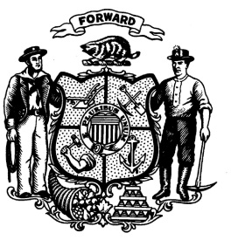 | ASSEMBLY CHAIR  JOHN NYGREN  309 East, State Capitol  P.O. Box 8953  Madison, WI 53708-8953  Phone: (608) 266-2343

JOINT COMMITTEE ON FINANCE

EXECUTIVE SESSION

Tuesday, May 9, 2017 (11:00 a.m.)

The Joint Committee on Finance will meet in Executive Session on the 2017-19 biennial budget on Tuesday, May 9, 2017, at 11:00 a.m. The meeting will be held in Room 412 East, State Capitol. The Executive Session will be held on the budgets of the following agencies:

Child Abuse and Neglect Prevention Board
Secretary of State
Wisconsin Economic Development Corporation
Military Affairs
Legislature
Justice

ALBERTA DARLING  Senate Chair |  | JOHN NYGREN  Assembly Chair

AD/JN/jm

