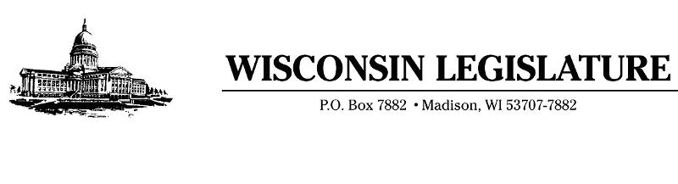  
April 3, 2020

Governor Tony Evers  
P.O. Box 7863  
Madison, WI 53707

Dear Governor Evers:

The CARES Act is a one-time federal windfall that must be spent wisely to help Wisconsin deal with the human and economic catastrophes caused by the coronavirus outbreak. As we learned late last week, Wisconsin will be awarded $2.2 billion, with $1.9 billion of that headed directly to the state.

Because of the seriousness of this pandemic, we believe in the importance of setting aside partisan differences and working together. We hope you believe the same.

Over the past two weeks, we have spoken to thousands of Wisconsinites. We have reached out to our local health care providers, business owners, farmers, and local governments to understand their most pressing concerns during this very trying time. As you know, you and your administration have the sole ability to allocate the federal stimulus money, so we would like to outline what we believe are the main priorities of Wisconsinites statewide.

When it comes to healthcare, you have likely heard as we have, that nursing homes are struggling terribly to pay for the necessary personal protection equipment (PPE) that is needed to follow CDC guidelines. Our nursing home workers are on the frontlines of this pandemic. If they are not able to adequately keep residents safe, it will directly impact our hospitals. In addition, PPE is still a need for healthcare and other essential workers across the state. The state also must have more readily available and rapid testing supplies. We hope you will **prioritize the needs of hospitals and healthcare facilities** as you spend these federal resources. We ask that you continue to derive the most accurate data possible as it relates to hospital usage, patient outcomes, and test results so that our healthcare workers can provide the best care possible.

While we believe our priorities align on these issues related to healthcare, we know they diverge when it comes to protecting unborn life. We must voice our strong opposition to classifying abortion providers, such as Planned Parenthood, as an essential service. Considering the federal government has provided guidance shutting down all elective procedures in our hospitals to conserve precious resources and PPE, it is unconscionable that you would allow these facilities to continue to operate. The PPE should be conserved for those frontline healthcare workers battling COVID 19, many of whom are asked to reuse the same mask for days. While we have little hope that you will change your mind on this, we must firmly insist that no federal stimulus money go directly or indirectly to abortion providers.

Our economy is going to suffer greatly because of this shut down. The Federal Reserve is predicting the crisis could drive the national unemployment rate to 32% and the GDP could suffer a 20% decline. In Wisconsin, economists project 15% of our state workforce could be unemployed as soon as this summer. Please consider **safeguards for our business owners and workers.** We have said publicly we are in favor of repealing the one-week waiting period for unemployment and will look to take it up as soon as the Legislature convenes. We would like you to consider building in unemployment assistance for business owners and direct any other resources available to help business owners and farmers stay afloat in these difficult times.

Also our local governments will no doubt be stretched thin due to the extra costs related to PPE procurement, increased use of fire, police and EMS services, and increased costs for absentee ballot mailings. We would ask that the state provide **assistance to our local governments**, if allowed under the purview of the federal stimulus bill. In addition, our homeless population will continue to struggle. Providing vouchers so that local governments can find alternate housing for those who lack shelter as well as finding ways to support our food pantries would also be worthwhile endeavors.

We know that this pandemic is going to bring with it a high price tag. These stimulus dollars will help stem the tide that we know is going to affect our state finances. Very soon, you will instruct state agencies to craft their state budget requests. These economic uncertainties are going to make that a difficult task, as we have no idea how far our revenues will fall. Please use every tool at your disposal, including the state offices of Inspector General within your administration, to be as mindful as possible in your spending decisions. In the upcoming fiscal year and the next budget, we will have to be more careful than ever. Considerations like **tax increases or other economically detrimental policies cannot and should not be an option.**

Finally, during this crisis, it is more important than ever that we allow Wisconsinites to observe their individual faiths. To that end, we ask that you work with Wisconsin churches and temples to allow them to hold Easter or Passover services, even if it’s outside. For many of us, being a part of these services will offer much-needed solace during these uncertain times.

Sincerely,

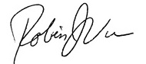 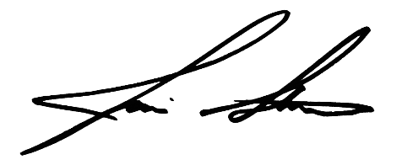

Rep.Robin J. Vos Rep. Jim Steineke  
Assembly Speaker Majority Leader

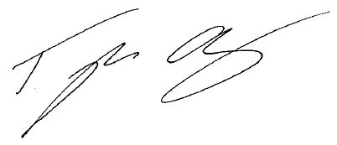 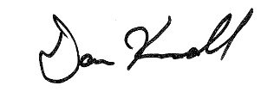

Rep. Tyler August Rep. Dan Knodl  
Speaker Pro-Tempore Majority Caucus Chair  
  
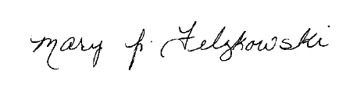 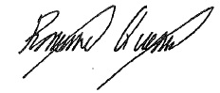

Rep. Mary Felzkowski Rep. Romaine Quinn  
Assistant Majority Leader Majority Caucus Vice-Chair  
  
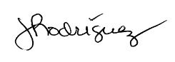 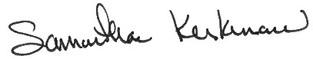

Rep. Jessie Rodriguez Rep. Samantha Kerkman  
Majority Caucus Secretary Caucus Sergeant At Arms

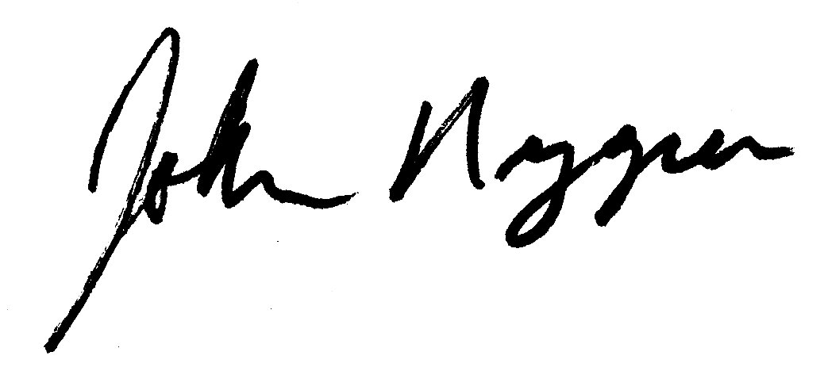 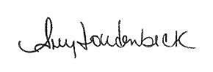

Rep. John Nygren Rep. Amy Loudenbeck  
Assembly Chair Assembly Vice-Chair  
Joint Committee on Finance Joint Committee on Finance

 

Rep. Joan Ballweg Rep. Mark Born  
41st Assembly District 39th Assembly District

 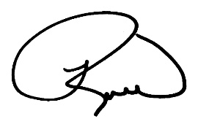

Rep. Janel Brandtjen Rep. Robert Brooks  
22nd Assembly District 60th Assembly District

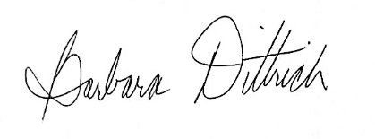 

Rep. Barbara Dittrich Rep. Cindi Duchow  
38th Assembly District 99th Assembly District

 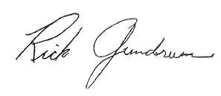

Rep. James Edming Rep. Rick Gundrum  
87th Assembly District 58th Assembly District

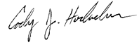 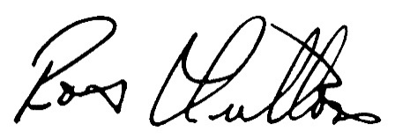

Rep. Cody Horlacher Rep. Rob Hutton  
33th Assembly District 13th Assembly District

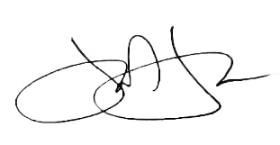 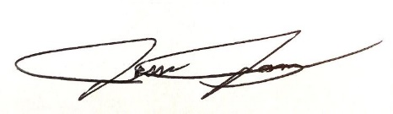

Rep. John Jagler Rep. Jesse James  
37th Assembly District 68th Assembly District

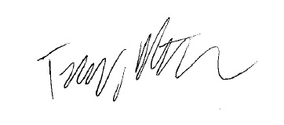 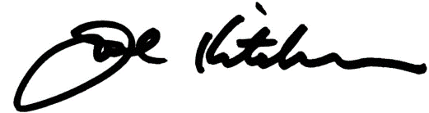

Rep. Terry Katsma Rep. Joel Kitchens  
26th Assembly District 1st Assembly District

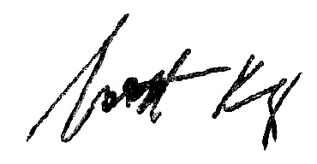 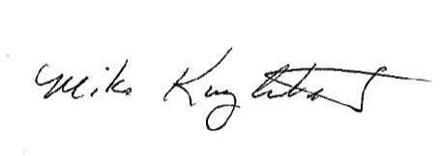

Rep. Scott Krug Rep. Mike Kuglitsch  
72th Assembly District 84th Assembly District

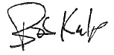 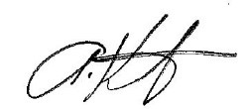

Rep. Bob Kulp Rep. Tony Kurtz  
69th Assembly District 50th Assembly District

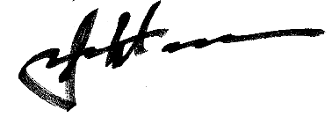 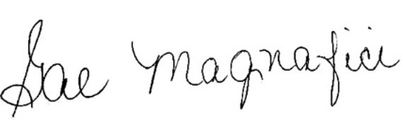

Rep. John Macco Rep. Gae Magnafici  
88th Assembly District 28th Assembly District

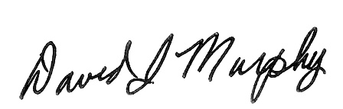 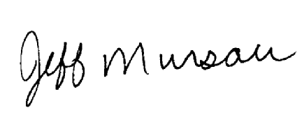

Rep. Dave Murphy Rep. Jeffrey Mursau  
56th Assembly District 36th Assembly District  
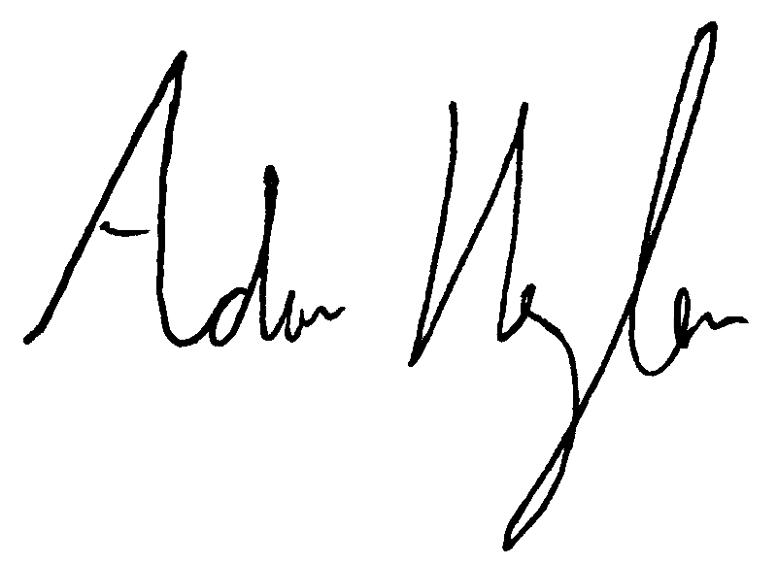 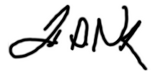  
Rep. Adam Neylon Rep. Todd Novak  
98th Assembly District 51st Assembly District

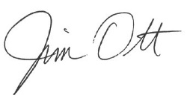 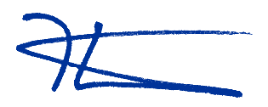

Rep. Jim Ott Rep. Kevin Petersen  
23rd Assembly District 40th Assembly District

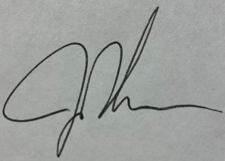

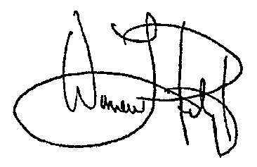 Rep. Warren Petryk Rep. Jon Plumer  
93rd Assembly District 42nd Assembly District  
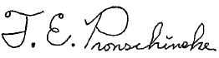 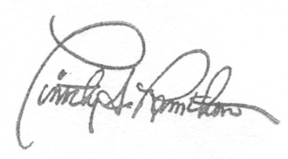  
  
Rep. Treig Pronschinske Rep. Timothy Ramthun  
92nd Assembly District 59th Assembly District  
  
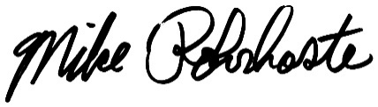 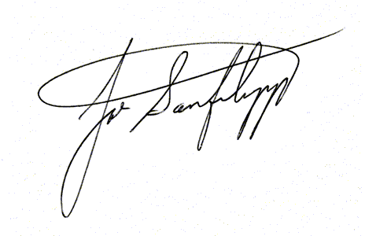

Rep. Mike Rohrkaste Rep. Joe Sanfelippo  
55th Assembly District 15th Assembly District

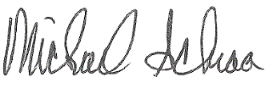 

Rep. Michael Schraa Rep. Ken Skowronski  
53rd Assembly District 82nd Assembly District

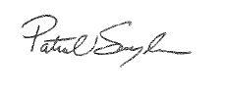 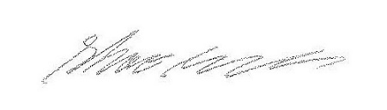

Rep. Pat Snyder Rep. Shae Sortwell  
85th Assembly District 2nd Assembly District

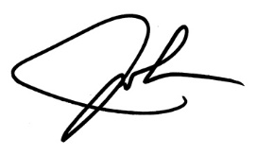 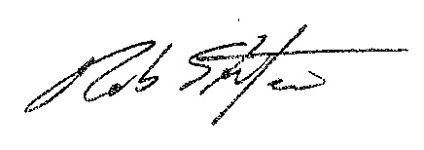

Rep. John Spiros Rep. Rob Stafsholt  
86th Assembly District 29th Assembly District

 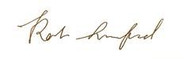

Rep. David Steffen Rep. Rob Summerfield  
4th Assembly District 67th Assembly District

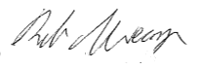 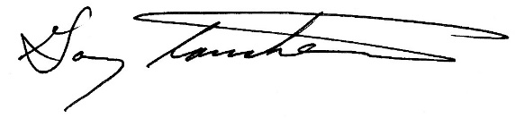

Rep. Rob Swearingen Rep. Gary Tauchen  
6th Assembly District 6th Assembly District

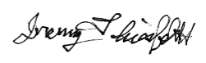 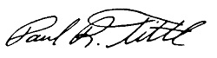

Rep. Jeremy Thiesfeldt Rep. Paul Tittl  
52nd Assembly District 25th Assembly District

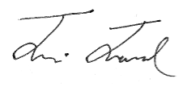 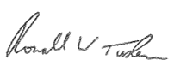

Rep. Travis Tranel Rep. Ron Tusler  
49th Assembly District 3rd Assembly District  
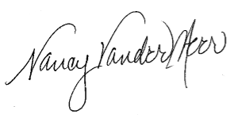 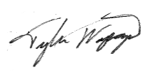  
  
Rep. Nancy VanderMeer Rep. Tyler Vorpagel  
70th Assembly District 27th Assembly District

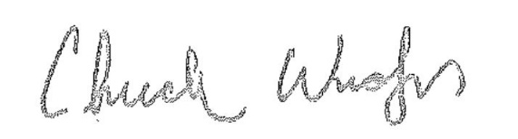 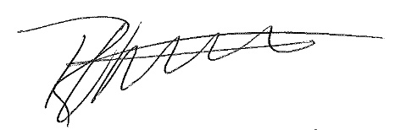

Rep. Chuck Wichgers Rep. Robert Wittke  
83rd Assembly District 62nd Assembly District

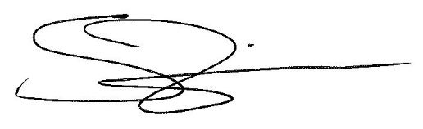

Rep. Shannon Zimmerman  
30th Assembly District