Phone 630 505 0160
www.wqa.org
David Loveday, Global Government Affairs Director
Kathleen Fultz, Global Regulatory and Government Affairs Manager
Wisconsin: PFAS

State Regulation:
There is currently no state level regulation on PFAS chemicals in Wisconsin.
PFAS Detection:
PFAS chemicals have been detected in Wisconsin through the U.S. Environmental Protection Agency’s (US EPA) third Unregulated Contaminant Monitoring Rule (UCMR 3) program, along with other PFAS monitoring programs.
A Snapshot of Occurrence Data & State Actions in the Region:

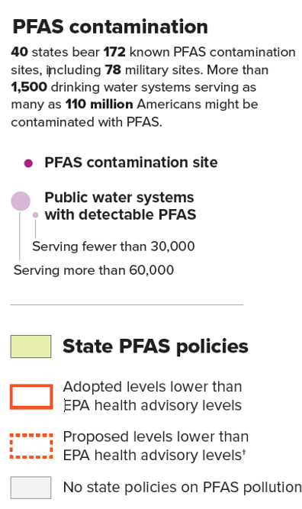

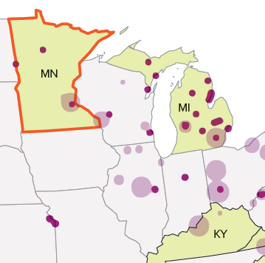

Sources: Journal of Exposure Science & Environmental Epidemiology, Safer States. Map sources: Environmental Working Group, SSEHRI at Northeastern University
By Patterson Clark, POLITICO Pro DataPoint
Analysis of 2013−2015 national drinking water PFAS concentrations from the U.S. Environmental Protection Agency’s (US EPA) third Unregulated Contaminant Monitoring Rule (UCMR3) program. Studies have found drinking water supplies for 6 million U.S. residents exceed US EPA’s lifetime health advisory (70 ng/L) for PFOS and PFOA. Lower analytical reporting limits and additional sampling of smaller utilities and private wells would greatly assist in further identifying PFAS Contamination sources.

Wisconsin: Nitrate/ Nitrite

State Regulation:
Wisconsin follows the U.S. Environmental Protection Agency’s (EPA) Maximum Contaminant Level (MCL) for nitrates in drinking water, set at 10 mg/L and for nitrites at 1 mg/L. This is an enforceable limit for public water systems only.
Nitrate Detection:
The data in the table below, shows the total area and percent of state area predicted to have nitrate concentrations exceeding 5 mg/L, or half of EPA’s MCL, in groundwater used for drinking. Also presented is the estimated percent of state populations served by self-supplied drinking water, 98% of which is from groundwater wells.
State | Estimated area (mi²) of state with groundwater nitrate concentrations >5 mg/L | Estimated % of state area with groundwater nitrate concentrations >5 mg/L | Estimated % of population with self-supplied drinking water
Wisconsin | 1,231 | 2% | 30%
Minnesota | 3,229 | 4% | 22%
Iowa | 2,476 | 4% | 18%
Illinois | 3,132 | 6% | 9%
Michigan | 3,254 | 6% | 29%
Source: Estimated Nitrate Concentrations in Groundwater Used for Drinking
By U.S. Environmental Protection Agency
A Snapshot of Occurrence Data in the Region:
Areas at Risk of Nitrate Contamination to Shallow Groundwater
This map shows areas with the highest risk for contamination of shallow groundwater by nitrate.
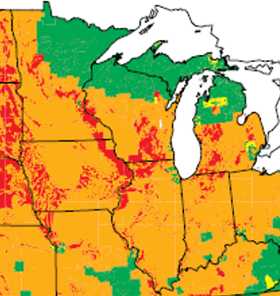
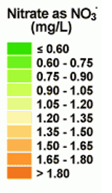

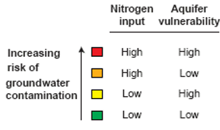

Source: US Geological Survey “The Quality of Our National’s Waters” (1999)
Wisconsin: Arsenic

State Regulation:
Minnesota follows the U.S. Environmental Protection Agency’s (EPA) Maximum Contaminant Level (MCL) for nitrates in drinking water, set at 0.010 mg/L, as of Jan. 23, 2006. This is an enforceable limit for public water systems only.
Arsenic Detection:
A new study by the U.S. Geological Survey and Centers for Disease Control and Prevention estimates about 2.1 million people in the U.S. may be getting their drinking water from private domestic wells considered to have high concentrations of arsenic
A Snapshot of Occurrence Data & State Actions in the Region:

Estimated Population with Arsenic > 10 µg/L
This map shows estimates of how many private domestic well users in each county may be drinking water with levels of arsenic of possible concern for human health (> 10 µg/L).

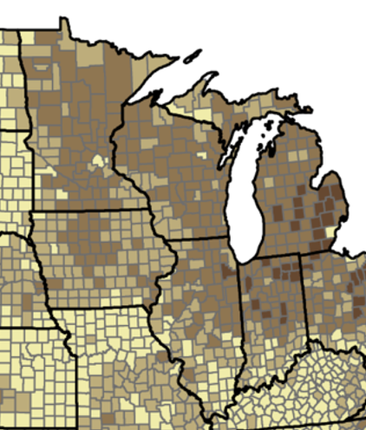

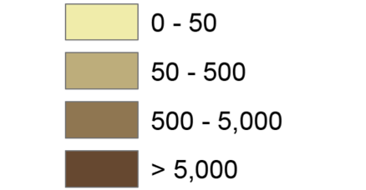

Source: Estimating the high-arsenic domestic-well population in the conterminous United States (Oct. 2017)
By J.D. Ayotte, L. Medalie, S.L. Qi, L.C. Backer, and N. T. Nolan

